River Forest Mental Health Committee
Minutes March 5th, 2024 at 6:30pm - Zoom & In-Person Meeting

Present: Elizabeth Davies, Angie Grover, Melinda Peterson, Kathryn Schmahl, Kristin Sneeringer, Jessica Starck, MD, Phillip Buta (zoom)
Absent: Helene Connolly, Jonathan Howard, MD
Staff: Sarah Schwarting, LCSW, Mental Health Administrator

- Melinda called the meeting to order at 6:31 p.m. and conducted roll.
- Public Comments: Sarah Schwarting and Kristin Sneeringer
  - Positive Intelligence, a book written by Shirzad Chamine, speaks to the factors that relate to fulfilling one’s potential, which both Sarah and Kristin have found useful and applicable
  - Positive Intelligence Quotient is improved by the following:
    - Decreasing saboteurs (negative talk)
    - Empathy
    - Exploration
    - Innovation
    - Navigation
    - Activation
- Sarah and Kristin recommended the book as a way to achieve goals and improve mental wellness.
- Jessica moved to approve the minutes from February 6th, 2024, Angie seconded and the motion was carried.
- Township Report and Mental Health Administrator Report, read by Sarah:
  - Parent University will be held on April 10th at 6 pm at OPRF HS. Keynote speaker, Dr. Devorah Heitner, will be sharing insights about teens and social media in addition to offering workshops for parents.
  - River Forest Township’s Youth and Family Services and Mental Health Committees are voting this month on funding recommendations for FY2025. These recommendations will be shared with the Township’s Board of Trustees for its consideration and final decision in the coming months.
  - Positive Youth Development (PYD) is being restructured given a shift in staffing. PYD will be considering providing focused prevention activities in the coming months. The Opioid Task Force is being revived and the next planning meeting will be March 12th at 11am.
  - The Intergovernmental Agreements (IGA’s) with Oak Park Township related to Senior Services, Youth and Family Services, Youth Engagement Program and General Assistance all renew this year. We are working on updating the IGA’s with the new OPT Manager, Evan Michel.
  - The Efficiency Report mandated by statute to be completed by Illinois Townships and other taxing bodies will be completed this month for River Forest Township. We appreciate the input of our three resident committee members Barb Hickey, John Phelan and Melinda Peterson, as well as Trustee Deana Hermann and her NIU grad student intern.
  - Our Assessor’s office continues to be busy. First half tax bills were due March 1, and we are now open for appeals, senior aid and other exemptions this month. We anticipate a very busy month, especially as we continue to help seniors navigate their property taxes.

- Other Updates from MHC Members: None
- Old Business:
  - Review of Funding Applications: the committee discussed each agency’s grant application and made recommendations on funding. The committee’s recommendations are shown in the table below.
  - Jessica moved to recommended the following grant funding for FY2025, Elizabeth seconded and the motion was carried.

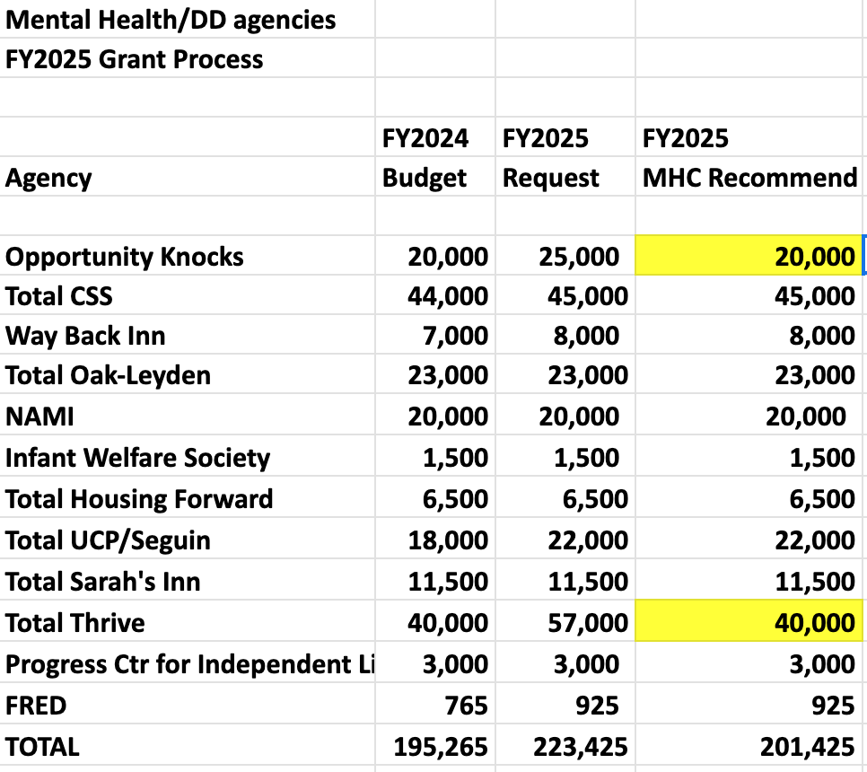

- New Business: None
- The next meeting will be Tuesday, April 2nd, 2024 at 6:30 pm at the River Forest Community Center.
- Angie motioned to adjourn and Elizabeth seconded. The meeting was adjourned at 7:43 p.m.

